Virtual Network Orchestrator (ViNO) User Guide

Software Version 1.0.1

February 4, 2020

©2020 CenturyLink. All Rights Reserved. The CenturyLink mark, pathways logo and certain CenturyLink product names are the property of CenturyLink. All other marks are the property of their respective owners.

Contents

Introduction 1

ViNO Software Components 2

ViNO Keycloak Roles and Groups 3

ViNO Homepage 4

Accessing Keycloak Account Settings 5

Service Activations and Service Detail Sections 5

Displaying Service Details 8

Deactivating a Service 9

Reactivating a Service 9

Displaying and Hiding Service Entries 9

Activating a Service 10

Application Settings Menu–Settings Management 13

Using Settings Categories 15

Adding a Settings Category 15

Modifying the Display Name in a Settings Category 15

Using Groups 16

Adding a Group 16

Modifying the Display Name for a Group 17

Using Scalars 17

Adding a Scalar 18

Modifying a Scalar 19

Using Scalar Lists 19

Adding a Scalar List 19

Modifying the Display Name for a Scalar List 20

Downloading and Uploading a JSON File 20

Downloading a JSON File 21

Uploading a JSON File 21

Deleting Elements 22

Application Settings–User Management 22

Service Manager 22

Service Manager Components 24

Service Manager Concepts 26

Creating or Cloning a Project 27

Creating a Project 28

Cloning a Project Repository 28

Saving a Project 29

Working in the Service Designer 29

Working in the Palette 30

Managing Nodes in the Palette Manager 31

Accessing the Palette Manager 31

Managing Nodes 32

Adding Nodes to the Palette 33

Using Built-In or Third-Party Node-RED Nodes 33

Working with Flow Tabs 34

Adding a Flow Tab 35

Editing Flow Tab Properties 35

Enabling or Disabling a Flow Tab 35

Deleting a Flow Tab 35

Switching Between Flows 35

Working with Nodes 36

Using the Inject Node 37

Using the Debug Node 37

Using the Function Node 37

Using the Change Node 38

Using the Switch Node 38

Using the Template Node 38

Using ViNO Nodes 39

Using Conditional Start and Conditional End Nodes 42

Adding Status Messages to Built-In Nodes 43

Using the Function Node to Manipulate Parameters 44

Working with Wires 44

Moving Wires 45

Deleting Wires 45

Working with Subflows 45

Designing a Subflow 47

Working with Messages 48

Changing Message Properties 48

Using the Service Status Node 48

Working with the Sidebar 49

Using Parameters 50

Configuring Parameters on Nodes 51

Editing Parameters 56

Using Parameter Mapping 57

Using Parameter Mappings and Conditionals 57

Using Parameter Wrapper Injection and Extraction 58

Using Parameter Combiner Modes 58

Passing Parameters Between a Parent Flow and Subflow 59

Using Loops 61

Using Basic Loops 61

Considerations for Each Loop 62

Using Input Parameters in a Loop Step 63

Using Parameter Mapping and Loops 63

Using Parallel Execution 64

Joining Parallel Branches 64

Creating a Service Deactivation Flow 66

Error Handling 68

Using the Catch Node 68

Using the Throw Node 68

Adding Rollback Capability 69

List of Tables

Table 1. ViNO Components 2

Table 2. ViNO Keycloak Roles and Permissions 3

Table 3. ViNO Homepage Navigation Bar 4

Table 4. Service Activations Section 7

Table 5. Service Details Field Descriptions 8

Table 6. Service Activation Screen 10

Table 7. Settings Management Screen 14

Table 8. New Scalar Field Descriptions 18

Table 9. Service Manager Components 24

Table 10. Service Manager Concepts 26

Table 11. ViNO Nodes 39

Table 12. Property Edit Window 52

List of Figures

Figure 1. ViNO Homepage 6

Figure 2. Service Activation Screen 11

Figure 3. Service Activation Details Screen 12

Figure 4. Settings Management Screen 14

Figure 5. JSON Upload and Download Buttons 20

Figure 6. Service Manager Screen 23

Figure 7. Service Manager Screen in a New ViNO 27

Figure 8. Filter Node Field and Toggle Palette 30

Figure 9. User Settings Window 32

Figure 10. User Settings–Nodes List in Palette Tab 32

Figure 11. Palette Install Tab 33

Figure 12. Service Manager Flow Tab Navigation Bar 34

Figure 13. Edit Flow Sidebar 34

Figure 14. Example of Using the Conditional Start Node 42

Figure 15. Example of Using the Conditional End Node 43

Figure 16. Example of Using Conditional Start and Conditional End Nodes 43

Figure 17. Working with Wires 44

Figure 18. Dropping a Node on a Wire 45

Figure 19. Create Subflow Option 46

Figure 20. Example of New Subflow and Toolbar 46

Figure 21. Subflow Example 47

Figure 22. Service Manager Sidebar 49

Figure 23. Property Edit Window 51

Figure 24. Edit Input Parameter Window 56

Figure 25. Mode Field in Property Edit Window 58

Figure 26. Using a Parameter Wrapper Node 60

Figure 27. Example of a Basic Loop 61

Figure 28. Using Input List in a Loop 62

Figure 29. Loop Start Node Example 62

Figure 30. Example of Creating a Parallel Branch 64

Figure 31. Example of Joining Parallel Branches 64

Figure 32. Example of Join Node Properties 65

Figure 33. Service with Corresponding Deactivation Flow 66

Figure 34. Deactivation Flow Example 67

Figure 35. Implementing a Rollback 69

# Introduction

This document describes how to use the Virtual Network Orchestrator (ViNO) to develop services and flows in order to:

* Create, activate, deactivate, and manage virtual services on OpenStack, NFVi platforms, and servers
* Manage virtual service network interfaces
* Use ViNO nodes to interact with OpenStack controllers in order to manipulate Virtual Machines (VMs)
* Interact with servers using robust Ansible support

In addition to this guide, ViNO documentation includes the *Virtual Network Orchestrator (ViNO) Installation Guide*, which describes how to install and initialize a ViNO instance and how to create a realm in Keycloak. ViNO uses [Keycloak](https://www.keycloak.org/) for authentication.

ViNO enables you to create, activate, deactivate, and manage virtual services for:

* Servers
* Firewalls
* Routers
* SD WANs

ViNO is built on [Node-RED](https://nodered.org/), which is a browser-based editor for wiring together flows using a wide range of nodes in the palette that can be deployed to its runtime in a single click.

The Node-RED site contains detailed information and user documentation on using the product. The expectation is for ViNO users to use the [Node-RED documentation](https://nodered.org/docs/) to familiarize themselves with the product functionality before using ViNO to create service flows.

ViNO builds on the flow-based model provided in Node-RED by including the following components specific to creating, configuring, and delivering services:

* VNF-specific nodes that enable you to define how data is passed between the steps within in a flow.
* A backing web service API that enables new nodes to provide interfaces to complex network management actions.
* A management user interface.
* An authentication abstraction.
* Drivers that provide access to the Netconf protocol, Ansible, and the OpenStack V3 API.
* REST APIs that provide a unified and consistent interface for managing the full life cycle of service activation, deactivation, and management.

The additional nodes included in the software enhance the functionality of Node-RED by enabling ViNO to programmatically and automatically generate activation templates that have full compatibility with existing Node-RED default nodes, as well as many of the community-contributed nodes available on the internet.

The difference between a ViNO service and a Node-RED flow is that a ViNO service must always start with a **service entrypoint** node and end with a **service endpoint** node.

# ViNO Software Components

The ViNO software is comprised of several components as described in Table 1.

Table 1. ViNO Components

|  |  |
| --- | --- |
| Component | Description |
| **NGINX** | A lightweight, high performance HTTP proxy, load balancer, and web host. In the ViNO software suite, NGINX serves the role of an HTTP reverse proxy to expose select services inside a local private network and access them from the Docker host system. |
| **Service Manager** | A combination of an unmodified Node-RED installation and a custom user interface on top. The Node-RED instance has been branded for CenturyLink and includes several custom nodes that provide the ability to create service flows that can be activated programmatically and registered with an API instance. |
| **ViNO API** | An Express.js-based REST interface that provides service registration, activation, history, and status monitoring as well as hosts several protocol drivers that enable the Service Manager to interact with remote devices using Netconf, Ansible, and Openstack APIs. |
| **Settings Server** | Provides a hierarchical data store that enables users to define groups of settings and variables. |
| **Keycloak Authentication Server** | ViNO uses the [Keycloak](https://www.keycloak.org/) authentication server to provide local authentication and the ability to incorporate federated authentication methods such as Kerberos or LDAP. In addition, ViNO can use Single Sign On (SSO) Identity Providers (IdPs) over SAML or OpenID Connect (OIDC).  This component alleviates the need to log into each individual piece of the ViNO software suite. It also simplifies the process of integrating the open source projects that comprise ViNO into the corporate authentication mechanisms. |
| **PostgreSQL Database** | ViNO uses a PostgreSQL database to store various pieces of information such as the configuration for authentication and the history of activations including service input and output. |

# ViNO Keycloak Roles and Groups

ViNO Keycloak roles each have unique permissions that apply to users assigned a role or multiple roles.

* **Roles** are permission-centric. Roles apply permissions to users.
* **Groups** are user-centric. They are a collection of users. Use groups to manage users.

Menu options differ depending on the role you are assigned. For example, a user assigned only the operator role cannot view the **Service Manager**, **Activate a Service**, or **Application Settings** menus.

ViNO provides four roles that correspond to different permissions. Table 2 defines the roles and their permissions.

Table 2. ViNO Keycloak Roles and Permissions

|  |  |
| --- | --- |
| Keycloak Role | Permissions |
| **administrator** | * Change settings in Settings Management. * View service details on the homepage. |
| **designer** | * Create and modify flows in Service Manager. * Activate services. * View Settings Management, but cannot edit the screen. * View service details on the homepage. |
| **provisioner** | * Activate and deactivate services. * View Settings Management, but cannot edit the screen. * View service details on the homepage. |
| **operator** | View service details on the homepage. This role is read-only. |
| **user** | Required role that provides basic access permissions to ViNO.  All users must be assigned this role in addition to at least one of the other four roles. |

## ViNO Homepage

The menu options on the homepage navigation bar differ depending on the role (administrator, designer, operator, or provisioner) your username is assigned. For example, a user assigned only the **operator** role cannot view the **Service Manager**, **Activate a Service**, and **Application Settings** menus.

Table 3 describes the menus located in the top navigation bar of the homepage. Figure 1 shows an example of the homepage.

Table 3. ViNO Homepage Navigation Bar

| Menu | Description |
| --- | --- |
| **Main – Homepage** | Displays the **Service Activations** and the **Service Detail** sections. Click **Main** to refresh or return to the homepage. |
| **Service Manager** | Displays the flow editing tool (**Service Manager**). Click ViNO-Service Manager to return to the home page. |
| **Activate a Service** | Enables you to select a service from the drop-down, enter customer information, and then progress through the configuration steps to activate the service. |
| **Application Settings** | Includes the following options:   * **Settings Management** – Enables you to add, remove, or modify settings categories and modify default scalar values and overrides. See Application Settings Menu–Settings Management. * **User Management** – Enables you to access the Keycloak Admin console. See Application Settings–User Management. |
| **Help** | Includes:  **Installed Docker Containers Details** – Displays the installed version of each ViNO component: vino-core, vino-database, vino-keycloak, and vino-proxy.  **Web Service Documentation** – Displays the ViNO REST services in Swagger. If you build software to call ViNO, use this option for a machine-to-machine interface. Use the browser Back button to return to the ViNO home page. |
| *Username*  (Displays the name of the user who is logged in) | Includes the **Account Settings** menu and the Log Out button.   * **Account Settings** menu – Provides access to Keycloak. See Accessing Keycloak Account Settings. * Log Out button – Click to log out of ViNO. |

## Accessing Keycloak Account Settings

The **Account Settings** option (in the *username* drop-down) enables you to access the Keycloak account manager. Keycloak displays the **Edit Account** screen by default and pre-populates your username in the **Username** field. The navigation bar at the top of the screen includes:

* **English** – Default language. Click the drop-down to select a different language that applies to the options in the **Account Settings** menu.
* **Back to vino-api** – Returns you to the ViNO homepage.
* **Sign Out** – Logs you out of Keycloak and ViNO.

The **Edit Account** screen includes the following options. Refer to the [Keycloak](https://www.keycloak.org/) documentation for information on using these options.

* **Account**
* **Password**
* **Authenticator**
* **Sessions**
* **Applications**

# Service Activations and Service Detail Sections

The homepage contains the following two sections, which are read-only:

* **Service Activations** – Enables a designer or provisioner to deactivate and reactivate services.
* **Service Detail** – Enables all users to view service details and details for the specific steps in a service. See Displaying Service Details.

The **Service Activations** section lists active and deactivated services. To filter the list of entries, enter criteria in the Search field (you do not have to click Enter). Search criteria applies to the data in all columns. Clear the criteria to re-display all entries.

Figure 1 shows an example of the homepage. To display information in the **Service Detail** section for a specific service, highlight the entry in the **Service Activations** section.

Figure 1. ViNO Homepage

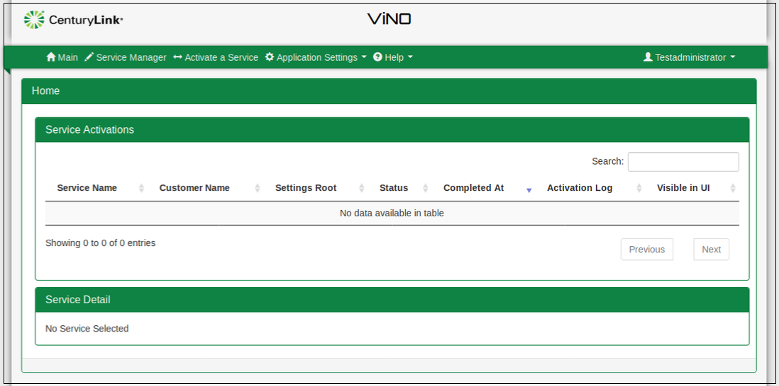

Table 4 describes the buttons and columns in the **Service Activations** section. Each column can be toggled to list the entries in either alphabetical or numerical order (ascending or descending).

Table 4. Service Activations Section

|  |  |
| --- | --- |
| Component | Description |
| **Deactivate Button** | Deactivates a service. Highlight the service entry in the **Services** section and click Deactivate. See Deactivating a Service. |
| **Reactivate Button** | Reactivates a service. Highlight the service entry in the **Services** section and click Reactivate. See Reactivating a Service. |
| **Show All Activations**  **Filter All Activations** | Displays all activations (service entries) irrespective of the **Visible in UI** column setting (Yes or No).  Hides service entries that have the **Visible in UI** column set to Yes.  See Displaying and Hiding Service Entries. |
| **Search Field** | Filter the list of entries. Search criteria applies to data in all columns. When the Search field is blank, ViNO displays all entries. When the Search field contains criteria, ViNO displays only those entries that match the search criteria. Clear the criteria to re-display all entries. |
| **Service Name Column** | Name of the service as defined in the associated flow. |
| **Customer Name** | Name of the customer associated with the service as defined in the associated flow. |
| **Settings Root** | Identifies the root group to use for all constants in the service activation. |
| **Status** | Status of the service (Activated or Terminated). |
| **Completed At** | Date and time stamp when the service activation or deactivation was completed. The time stamp is UTC (Coordinated Universal Time). |
| **Activation Log** | Configuration log of a service activation. Click Close to close the log or click Download Log to open and save the file. |
| **Visible in UI Column** | Displays (Yes) or hides (No) an entry. The default is Yes. See Displaying and Hiding Service Entries. |

## Displaying Service Details

The **Service Detail** section displays information about a service and about each step in the flow. This information is historical and is helpful for troubleshooting. To display information for a service, select the service in the **Services** section.

Table 5 describes the fields in the **Service Detail** section.

Table 5. Service Details Field Descriptions

|  |  |
| --- | --- |
| Field | Description |
| **Job ID** | Identifier for the service Activation log. ViNO automatically assigns and updates the job ID. |
| **Customer Name** | Name of the customer associated with the service as defined in the **Customer Info** section when you activate a service (**Service Activation** screen). |
| **Settings Root** | Identifies the root group to use for all constants in the service activation. |
| **Activation Status** | Displays the value listed in the [**Status**](#UsingtheVirtualNetworkOrchestrator(ViNO) column (**Service Activations** section). |
| **Activation Notes** | Notes associated with the service as defined in the **Customer Info** section when you activate a service (**Service Activation** screen). |
| **Select Step for Details** | Drop-down that lists each step in a flow as defined by the designer. |
| **Input Parameters**  and  **Output Parameters** | Select an entry from the **Select Step for Details** drop-down to display the InputandOutput parameters defined by the designer for that specific node. Both parameter sections include the following columns:   * **Parameter Name** – Name of the parameter defined in the flow. * **Parameter Description** – Description of the parameter defined in the flow. * **Parameter Type** – Type of parameter (for example, string, Boolean, number, enumeration) defined in the flow. * **Parameter Value** – Value of the parameter defined in the flow. |

## Deactivating a Service

When you deactivate a service, ViNO tears down the service configuration, but retains the configuration information enabling you to easily reactivate the service if needed.

A flow must have a deactivation path defined to in order to deactivate the service.

To deactivate a service:

1. Select the service that you want to deactivate.
2. Click Deactivate. ViNO displays a confirmation window.
3. Click OK to proceed with deactivating the service. The Deactivate Service log opens and displays the progress. When the process is complete, the last entry in the log displays: Service deactivation completed successfully.
4. Click OK to close the log. ViNO updates the service status to Terminated.

## Reactivating a Service

To reactivate a service:

1. Select the service that you want to reactivate.
2. Click Reactivate. ViNO displays a confirmation window.
3. Click OK to proceed with reactivating the service. The Activating Service log opens and displays the progress. When the process is complete, the last entry in the log displays: Service activation completed successfully.
4. Click OK to close the log. ViNO adds a new activation entry to the **Service Activations** section.

## Displaying and Hiding Service Entries

The Visible in UIcolumn (homepage > **Services** section) enables you to display or hide service entries. The default setting is Yes (display an entry). To hide an entry, change the setting to No. To display all entries irrespective of the entry setting, click Show All Activations. To hide entries that are set to No, click the button, which changes to Filter Activations.

## Activating a Service

The **Activate a Service** menu displays the **Service Activation** screen, which enables a user assigned the administrator or the provisioner role to select a service to be activated. Table 6 describes the sections and fields in the **Service Activation** screen.

Table 6. Service Activation Screen

| Section | Description |
| --- | --- |
| **Service Info** | Includes the **Service Name** and the **Description** fields, which ViNO populates. |
| **Customer Info** | Includes the following fields:   * **Settings Root** – (Required) Select the root group to use for all constants in the service activation. * **Customer Name** – Enter the customer name associated with the service. * **Notes** – Enter specific information about the service. |
| **Service Steps** | Lists the steps in a flow that are required to create a service. Select a node to display its parameters (default, custom, or pre-configured).  Each node includes the following fields:   * **Name** – Name of the node as entered by the designer. * **Node ID** – System-generated unique identifier. * **Description** – Text entered by the designer in the Edit panel of a node. |
| **Parameters** | Displays parameters assigned by a designer for each node in a flow.   * **Show Pre-Configured Parameters** – Displays node parameters that have pre-assigned values. To enter or update a parameter, double-click the field. A field can still be updated when it is greyed-out. To cancel an update, refresh the browser (which returns you to the home page). * **Hide Pre-Configured Parameters** – Displays parameters (with or without assigned values) that apply to a node and hides parameters displayed by the **Show Pre-Configured Parameters** setting.   When a parameter has the **Final** checkbox selected (located in the **Edit Input Parameter** window), it is not displayed in the **Parameter** section in order to protect the integrity of a finalized flow. Parameters that have the **Final** checkbox selected can only be updated from the **Edit Input Parameter** window. |
| Back Button | Displays parameters for the previous service step. |
| Next Button | Displays parameters for the next service step. |

To activate a service:

1. Select a service from the **Service** drop-down (**Activate a Service** menu). ViNO auto-populates the **Service Name** and the **Description** fields with the information that was entered when the flow was created. Figure 2 shows the Create NBS VM service selected with information populated in the **Details** section.
2. ViNO only auto-populates the **Service** drop-down with services that start with a **service entrypoint** node.

Figure 2. Service Activation Screen

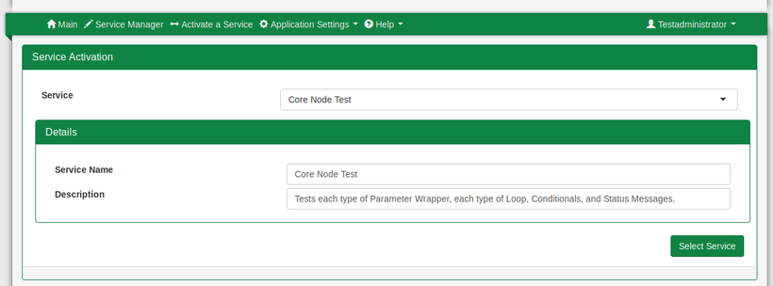

1. Click Select Service. The **Service Activation Details** screen displays the **Services Info**, **Customer Info**, and the **Service Steps** sections as shown in Figure 3.
2. Select an entry from the **Settings Root** drop-down (**Customer Info** section). The Settings Root identifies the root group to use for all constants in the service activation. ViNO populates the values in this  
   drop-down from the Settings Management entries.
3. (Optional) Enter the customer name in the **Customer Name** field. If you do not enter a name, ViNO auto-populates the value as *ViNO*.
4. (Optional) Enter notes pertaining to the customer or site (for example, site address) in the **Notes** field.
5. Select each step (or click the Next button) to display parameters for each step (**Service Steps** section). The parameters for each step correspond to a node in the flow (that contains values).
6. Populate parameters as needed by toggling through each step. Required fields are highlighted in red text and change to green text when you enter a value. Pre-populated variables appear greyed out in the **Service Activation** screen. To override a default value, double-click the field and confirm that you want to override the value, then enter the new value.
7. After you have toggled through each step, click Next to display the **Review and Activate** screen. This screen displays the service name, description, and the steps including their parameters (see Figure 3).

To activate a service without first checking the parameters for each step, select the last step in the flow, and then click Activate. In the **Review and Activate** screen, click Activate. If a step is missing a required parameter, an error message is displayed at the top of the screen.

Figure 3. Service Activation Details Screen

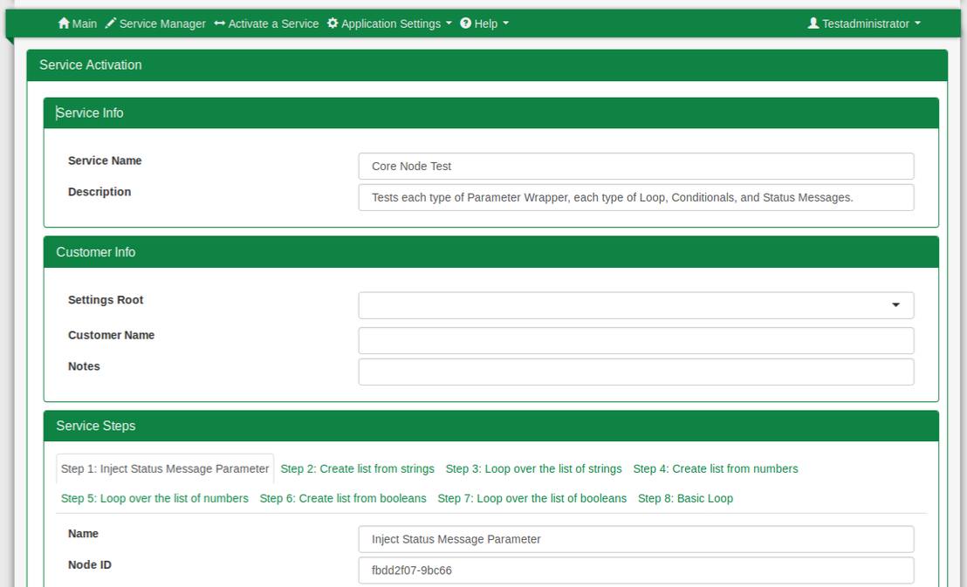  
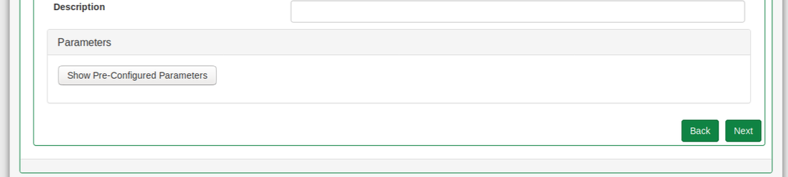

1. To proceed with activating the service, click Activate. To include ViNO debug messages in the activation log, select the **Run in Debug Mode** checkbox, then click Activate. To make additional changes to parameters, click Edit Service Parameters to return to the **Service Activation** screen.

When you click Activate, ViNO displays the following warning message:

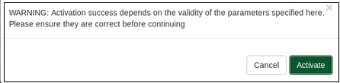

1. Click Activate to activate the service. ViNO displays a status log as shown below.

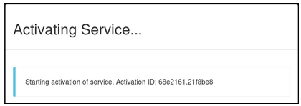

1. Click OK at the end of the status log to close the window.

# Application Settings Menu–Settings Management

The **Settings Management** screen (**Application Settings** menu) enables you to create, group, and store settings, elements, and scalars that can be used in services. Storing elements can provide variable default values to driver nodes. For example, a service may call for a different VM image or size based on the needs of a customer. The **Settings Management** screen enables you to store a group of settings that defines images and sizes, which can be passed in at service activation time rather than having to manually configure them each time or hard coding them into the flow.

To use constants in a ViNO service, see Constants.

The following sections describe each element in Settings Management:

* Using Settings Categories
* Using Groups
* Using Scalars
* Using Scalar Lists
* Downloading and Uploading a JSON File
* Deleting Elements

Only a user assigned the administrator role can edit and save values in the **Settings Management** screen. A user assigned the designer role can only view the **Settings Management** screen. If a designer updates this screen and tries to save the changes, an error message is displayed and the changes are not saved.

A new instance of ViNO does not include categories. You must create them manually or create them by loading the data using a JSON file. Settings management data is stored in JSON files. See Downloading and Uploading a JSON File.

An example of the **Settings Management** screen with three expanded categories is shown in Figure 4. Element names that are preceded with an asterisk ( **\*** ) are default elements. When you select an element, a window displays information for that element including options to add a group, a scalar list, or a scalar. If the element you select contains additional elements (such as groups, scalars, or scalar lists), the tree expands to display all the elements.

Figure 4. Settings Management Screen

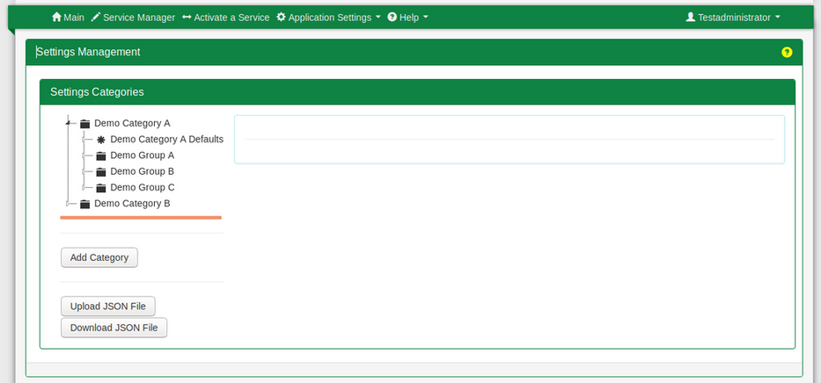

Table 7 describes the section and buttons on the **Settings Management** screen.

Table 7. Settings Management Screen

|  |  |
| --- | --- |
| Element | Description |
| **Settings Categories** | Top level element in **Settings Management**. Categories can contain groups, scalars, and scalar lists, which are displayed in a tree structure. |
| **Add Category** | Add a new category. |
| **Upload JSON File** | Load settings data from a JSON file to an instance of ViNO. |
| **Download JSON File** | Select and save categories to a JSON file. Use this file to load your saved categories to a new instance of ViNO. |
| **Apply Button** | Apply and save changes made to elements. |
| **Add Group** | Add a group to an element. |
| **Add Scalar List** | Add a scalar list, which functions similarly to a group except that you can only add scalars. Scalar lists do not allow groups to be added. |
| **Add Scalar** | Add values used in services. |

## Using Settings Categories

When you create a settings category, ViNO automatically creates a Defaults group and names it with the category display name. Each group that is added inherits the values from the initial Defaults group. Defaults groups cannot be deleted. However, you can add groups, scalars, and scalar lists to a Defaults group. Elements added to a Defaults group are automatically inherited by all groups for that category. Default values are identified by an asterisk ( **\*** ).

* Adding a Settings Category
* Modifying the Display Name in a Settings Category

### Adding a Settings Category

To add a new settings category:

1. Click Add Category. A window displays that enables you to enter values in the following fields:

* **Name** – Category name that is displayed in service definitions or during service activation. A name must be one word and can consist of letters, numbers, and hyphens. The **Name** field is a unique identifier and once set, cannot be changed.
* **Display Name** – Category name that is displayed in the UI (such as, the **Settings** screen and the **Service Activation** screen) to provide a display-friendly and readable name for the category. The **Display Name** field can contain multiple words (including letters, numbers, spaces, and hyphens).

1. Click Apply to save the new category.

### Modifying the Display Name in a Settings Category

To modify the display name for a category:

1. Highlight the category in the **Settings Categories** section. Highlighting a category expands the tree in addition to displaying information related to that category.
2. Click in the **Display Name** field, and then overwrite the existing name with the new name.
3. Click Apply.

## Using Groups

Groups are used to store other groups, scalars, and scalar lists. Groups are similar to categories, but they do not contain their own Defaults group.

Attributes for groups include:

* **Name** – Name that is displayed in service definitions or during service activation. A name must be one word and can consist of letters, numbers, and hyphens. The **Name** field is a unique identifier and once set, cannot be changed.
* **Display Name** – Name that is displayed in the UI (such as, the **Settings** screen and the **Service Activation** screen) to provide a display-friendly and readable name for the group. The **Display Name** field can contain multiple words (including letters, numbers, spaces, and hyphens).

Refer to the following sections for information on using groups:

* Adding a Group
* Modifying the Display Name for a Group

### Adding a Group

To add a new group:

1. Select a category or group in the tree. The properties window for that element is displayed.
2. Click the Add Group button. Alternatively, you can right-click a category or group and select Add > Group.
3. Enter a name in the **Name** field.
4. Enter a name in the **Display Name** field.
5. Click Apply to save the new group.

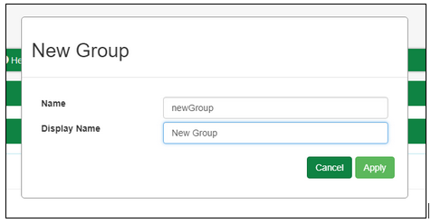

### Modifying the Display Name for a Group

To modify the display name for a group:

1. Select the group in the tree to open the **Group** window.
2. Click in the **Display Name** field, and then overwrite the existing name with the new name. For example:  
   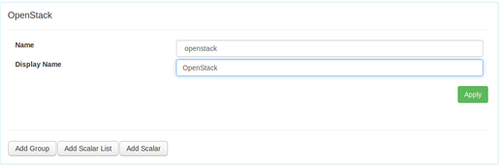
3. Click Apply to save your changes.

## Using Scalars

Scalars contain values that are used by ViNO services. Scalars can contain string, Boolean, or number values. You can also designate these values as required for service activation.

Scalars that are added to a:

* Defaults group are inherited by all groups.
* Non-default groups override inherited default scalars with the same name.

Refer to the following sections for information on using scalars:

* Adding a Scalar
* Modifying a Scalar

### Adding a Scalar

To add a new scalar:

1. Select a category, group, or scalar list in the tree, and then click Add Scalar. Alternatively, right-click on an element and select Add > Scalar.
2. Enter values in the **Name**, **Display Name**, **Required**, **Type**, and **Value** fields.
3. Click Apply to save the new scalar. For example:

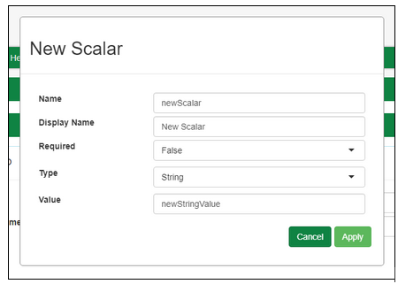

Table 8 describes the fields in the New Scalar window.

Table 8. New Scalar Field Descriptions

|  |  |
| --- | --- |
| Field | Description |
| **Name** | Scalar name that is displayed in service definitions and during service activation. A name must be one word and can consist of letters, numbers, and hyphens. The Name field is a unique identifier and once set, cannot be changed. |
| **Display Name** | Scalar name that is displayed in the **Settings** screen and the **Service Activation** screen to provide a display-friendly and readable name for the category. This field can contain multiple words (including letters, numbers, spaces, and hyphens). |
| **Required** | Determines whether a field is required (True) or optional (False). Select the appropriate option from the drop-down. |
| **Type** | Determines the value for the scalar. Select **String**, **Number**, or **Boolean** from the drop-down as appropriate. |
| **Value** | Value used by a ViNO service that references this scalar. The type of value that can be entered in this field is determined by the setting in the **Type** field for this scalar. |

### Modifying a Scalar

To modify a scalar:

1. Select the scalar in the tree. The values for the scalar attribute are displayed. The name in the **Name** field for a scalar is a unique identifier and once set, cannot be changed.
2. Enter changes by backspacing over existing values or by selecting a value from a drop-down.
3. Click Apply to save your changes. To cancel changes, refresh the page.

## Using Scalar Lists

Scalar lists enable you to categorize and store scalars. While scalars are not required to be stored in a scalar list, you may want to organize certain scalars together. For example, environment variables related to a specific system or a set of systems that share common architecture, such as the IP address, SSH username, SSH key, and password for a given system.

Scalar lists function similarly to a group except that you can only add scalars. Scalar lists do not allow groups to be added.

Refer to the following sections for information on managing scalar lists:

* Adding a Scalar List
* Modifying the Display Name for a Scalar List

### Adding a Scalar List

To add a new scalar list:

1. Select a category or group in the tree. The properties window for the selected element is displayed.
2. Click Add Scalar List. Alternatively, right-click the selected element and select **Add** > **Scalar List**.
3. Enter values in the Name and the Display Name fields in the **New Scalar List** window.
4. Click Apply to save the new scalar list.

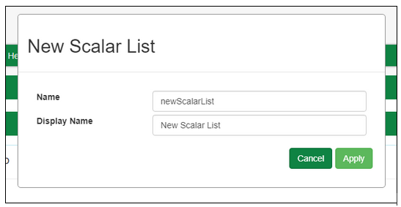

### Modifying the Display Name for a Scalar List

To modify the display name for a scalar list:

1. Click the scalar list in the tree. The scalar list properties window is displayed.
2. Click in the **Display Name** field, and then overwrite the existing name with the new name.
3. Click Apply to save your changes. To cancel the change, refresh the page.

## Downloading and Uploading a JSON File

ViNO enables you to save elements into a JSON file and then upload the file to another ViNO. Figure 5 shows the JSON file buttons on the **Settings Management** screen.

Figure 5. JSON Upload and Download Buttons

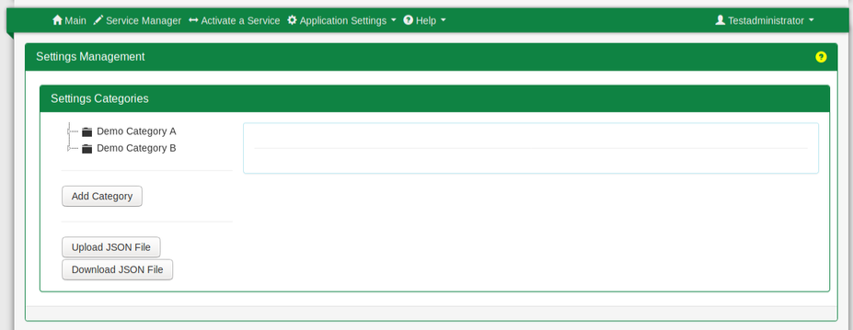

Refer to the following sections for information on using JSON files:

* Downloading a JSON File
* Uploading a JSON File

### Downloading a JSON File

Downloading enables you to save elements to a JSON file and then upload the file to another instance of ViNO.

To save elements to a JSON file:

1. Click the **Download JSON File** button (see Figure 5). A window opens enabling you to select which elements to save to a JSON file.
2. Navigate to the element you wish to save and select it.
3. Click Download.

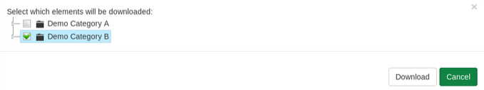

1. In the **Opening vino-settings.json** window:
2. Select the **vino-settings.json** checkbox. This is the default name. You can change this name as needed after the file is saved.
3. Select the action the browser should take.

* In Firefox, save the file to a location or open it.
* In Chrome, the filename appears in the bottom left of the screen. Click the down arrow to open the file or display it in your Download folder.

### Uploading a JSON File

Uploading a JSON file enables you to re-use previously saved elements in a settings category.

To upload a JSON file:

1. Click the **Upload JSON File** button (see Figure 5). The **Select a file to load** window is displayed.
2. Click Choose File, and then navigate to the location of the JSON file you wish to upload.

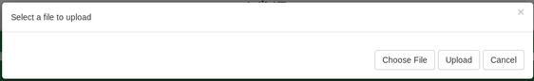

1. Select the file and then click Open. The file is displayed.
2. Scroll to the bottom of the file and click **Upload**. The new elements are uploaded and displayed in the **Settings Categories** section.

## Deleting Elements

**Caution**: All elements stored within a deleted settings category, group, scalar, or scalar list are also deleted. This process cannot be undone and the deleted values cannot be retrieved. Default groups cannot be deleted directly, but are deleted if the category is deleted.

To delete a settings category, group, scalar, or scalar list:

1. Right-click the element in the tree.
2. Select the Delete option. A warning confirmation message is displayed and requires you to confirm the action. The following example shows the confirmation message to delete the scalar list *LML Test*:

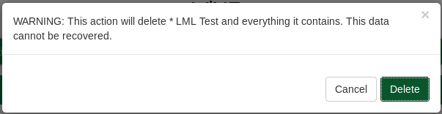

1. Click Delete to delete the element.

# Application Settings–User Management

The **User Management** option (**Application Settings** menu) opens the Keycloak homepage where you can access the Admin Console and the [Keycloak](https://www.keycloak.org/) documentation.

# Service Manager

The **Service Manager** enables a designer to create reusable network services by designing flows that represent the steps required to create a service. The main difference between a ViNO service and a Node-RED flow is that a ViNO service must always start with a service entrypointnode and end with a service endpoint node.

The term *flow* is used for a single set of connected nodes and for the tabs in the Service Manager, which can contain multiple flows (sets of connected nodes). A *project* includes all the flow tabs and subflows in the Service Manager.

The underlying technology is Node-RED with several additions to:

* Interact with Openstack.
* Configure services using Ansible and Netconf.
* Define how data is passed between steps within a flow.

ViNO can also leverage the nodes built in to Node-RED as well as an array of third-party nodes developed by the Node-RED community.

**Caution**: To avoid being logged out after 10 minutes while working in the Service Manager, you must open the Service Manager in a separate window. If you only have the Service Manager open, you are logged out of ViNO after 10 minutes with no warning. Even after being logged out, it appears that you can work and save in the Service Manager, but your changes are not saved.

Figure 6 shows a partial **Service Manager** screen that has the Ansible Hostname tab displayed.

Figure 6. Service Manager Screen

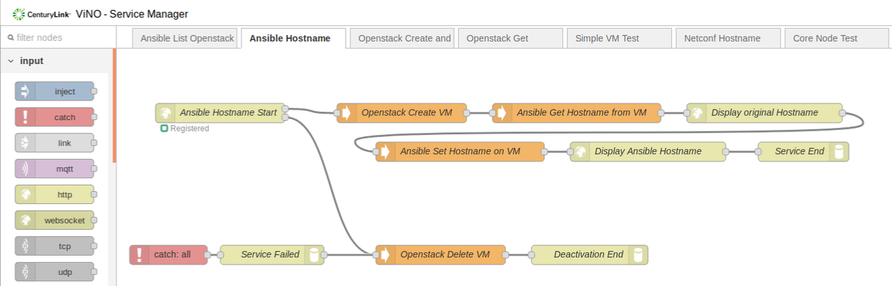

To display a description of a node in the Palette, hover your cursor over it.

To return to the homepage, click VINO-Service Manager located in the top left of the **Service Manager** screen.



## Service Manager Components

Table 9 describes the components on the **Service Manager** screen.

Table 9. Service Manager Components

| Component | Description |
| --- | --- |
| **Save icon** | Saves all flows for the project. This icon briefly changes into a loading icon during the process of saving the flows. |
| **Menu icon** | Drop-down that includes the following options:  **Projects**, **View**, **Import**, **Export**, **Search Flows**, **Configuration Nodes**, **Flows**, **Subflows**, **Manage Palette**, **Setting**, **Keyboard Shortcuts**, **Node-RED Website**, and *Node-RED software version*. Refer to the [Node-RED documentation](https://nodered.org/docs/) for information on these options. |
| **Designer workspace** | Create flows in this space. |
| **Right sidebar** | Includes the following informational displays. See Working with the Sidebar.   * C:\b692d84158f2868b74ffbe490834d414**info** – Displays information for the node currently highlighted. * C:\aeff53473fef78e1a924c62b203d1ea6**history** – Displays the history of your changes and enables you to revert or push changes to a Git repository. * C:\e0be02df64e3d0a6e19239a742cf0c24**debug** – Displays debug messages from the **debug** node. * C:\8b0ca8c34860ad05068e019eb48407a5Informational drop-down that includes the following options. When you select an option, its icon is added to the sidebar.   **Node information** – Same description as the **info** icon.  **Project history** – Same description as the **history** icon.  **Debug messages** – Same description as the **debug** icon.  **Configuration nodes** –N/A.  **Context data** – N/A. |
| **Node palette** | Located in the left panel of the screen. Includes the node categories listed below. |
| subflows | Set of connected nodes that can be reused within a larger flow. A subflow is represented as a single node in the workspace that can be opened in a tab to display the underlying flow. The **subflow** node category does not exist until a subflow is created. |
| input | Includes nodes that cover the basic communications mechanisms that applications are likely to use. The nodes range from UDP and TCP to the higher-level HTTP and the publish/subscribe MQTT (Message Queuing Telemetry Transport). |
| output | Essentially the mirror images of the basic set of input nodes that provide a way to send data on the same set of protocols (for example, MQTT, HTTP, UDP). |
| function | Nodes that carry out specific processing functions. Functions range from the simple **delay** and **switch** nodes to the programmable **function** node that can be adapted to most programming needs. |
| social | Basic social media nodes that support interaction with email and Twitter. These nodes enable flows to send or receive email or to send or receive tweets. |
| storage | Targeted at devices such as the Raspberry Pi. This category is limited and focuses on file-based storage. |
| analysis | Performs standard analyses on incoming messages. The only node provided is the **sentiment** node, which can be used to try to determine the sentiment of an incoming message based on the words used in the message (for example, an email or a tweet). |
| advanced | Miscellaneous nodes offering various types of functionality. |
| ViNO | Nodes used to create ViNO services.  The additional nodes included in the software enhance the functionality of Node-RED by enabling ViNO to programmatically and automatically generate activation templates that have full compatibility with existing Node-RED default nodes, as well as many of the community-contributed nodes available on the internet. |
| Raspberry Pi | Nodes specific to Raspberry Pi usage. |
| abacus | Nodes used to create web services with Node-RED. |

## Service Manager Concepts

The Service Manager enables you to access the designer functionality to create nodes and flows. Table 10 describes the concepts of the Service Manager functionality.

Table 10. Service Manager Concepts

| Concept | Description |
| --- | --- |
| **Flow** | Describes a single set of connected nodes. Click the Saveicon to save a flow. This term is also used to describe a tab in the Service Manager, which can contain multiple flows (sets of connected nodes). |
| **Parent Flow** | A parent flow contains subflows. |
| **Flow (Tab)** | A flow is represented as a tab at the top of the Service Manager workspace and is the main way to organize nodes. Use the **Project History** option (Informational drop-down) to save all flow tabs and subflows in the Service Manager (known as a *project*). |
| **Project** | Includes all the flow tabs and subflows in the Service Manager for the active project. Only one project may be active at a time. |
| **Subflow** | A subflow is a collection of nodes that are collapsed into a single node in the workspace. You can use subflows to reduce some visual complexity of a flow or to package a group of nodes as a reusable component used in multiple places. See Working with Subflows. |
| **Workspace** | The Workspace is the main area where you develop flows by dragging nodes from the palette and wiring them together. The workspace has a row of tabs along the top; one for each flow and subflow. See Working in the Service Designer. |
| **Node** | A node is the basic building block of a flow. Nodes are triggered by either receiving a message from the previous node in a flow or by waiting for an external event, such as an incoming HTTP request or a timer. A node processes the message or event and then may send a message to the next node in the flow. A node can have only one input port and as many output ports as it requires. See Working with Nodes. |
| **Configuration Node** | A **config** node is a special type of node that holds reusable configuration that can be shared by regular nodes in a flow. **Config** nodes do not appear in the main workspace, but can be seen by opening the Configuration Nodes option in the Menuicon drop-down (next to the Save button). See Working with the Sidebar. |
| **Message** | Messages are passed between the nodes in a flow. They are plain JavaScript objects that can have a set of properties. Messages are often referred to as **msg** within the editor. See Working with Messages. |
| **Wire** | Wires connect the nodes and represent how messages pass through the flow. See Working with Wires. |

## Creating or Cloning a Project

When you access the Service Manager on a new ViNO, you are presented with the options to create a project or clone an existing project from a Git repository. Cloning a repository maps your ViNO to the correct Git repository used to save your projects.

Figure 7 shows the **Service Manager** screen in a new ViNO.

Figure 7. Service Manager Screen in a New ViNO

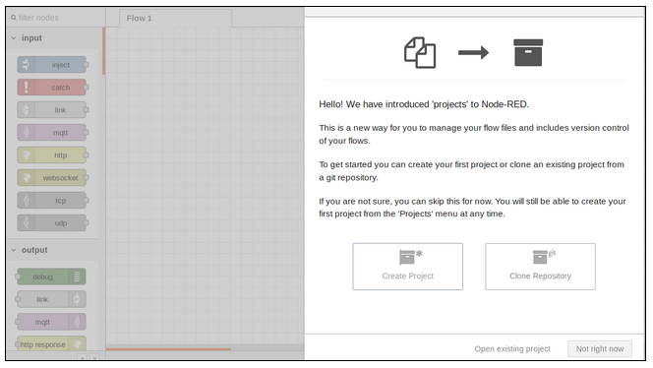

Refer to the following sections for information on creating and cloning projects:

* Creating a Project
* Cloning a Project Repository

### Creating a Project

To create a new Node-RED project:

1. Click Create Project.
2. Enter your username and email for your Git repository in the **Setup your version control client** window. Both fields are required.
3. Click Next.
4. Enter your project name (required) and an optional description in the **Create your project** window.
5. Click Next.
6. (Optional) You can configure a name for your flow file and credentials file that will be uploaded to your repository in the **Create your project files** window.
7. Click Next.
8. (Optional) You can provide a custom encryption key to protect the project files in your repository in the **Setup encryption of your credentials file** window.
9. Click Create Project. A success message is displayed.
10. Click Done.

### Cloning a Project Repository

Cloning a repository maps your ViNO to the correct Git repository used to save your projects.

To clone a repository:

1. Click Clone Repository (See Figure 7).
2. Enter your username and email for your Git repository in the **Setup your version control client** window. Both fields are required.
3. Click Next.
4. Enter the following values in the **Clone a project** window. All fields except for the credentials encryption key are required.
5. Your project name.
6. Repository URL for the project you wish to clone.
7. Enter your username and password for your Git repository.
8. Enter the credentials encryption key.
9. Click Clone Project. The project is loaded.

## Saving a Project

It is likely that the services you develop on your instance of ViNO will need to be deployed or shared with other ViNO instances. Therefore, it is important to save the flows that you create so they can be transferred easily between ViNO instances. Use the Project History icon or option in the Informational drop-down to save flow tabs and subflows by pushing the changes to a Git repository. This option also enables you to revert changes instead of saving them.

When you clone a Git repository, your ViNO Service Manager maps directly to a Git repository to provide a version control system for saving projects. The Git repository mapping is done when you clone a repository on a new instance of ViNO.

**Caution**: Do not use the **Import** or **Export** options (Menuicon drop-down) to share or save a project. These functions lose parameter mappings. See Using Parameter Mapping.

# Working in the Service Designer

The main workspace is where you develop service flows by dragging nodes from the palette and wiring them together. The workspace has a row of tabs along the top: one for each flow and subflow that is open.

The footer of the workspace includes buttons to zoom in and out as well as the ability to reset the default zoom level. The footer also includes a toggle button for the view navigator. The view provides a scaled down view of the entire workspace that highlights the area currently visible. You can drag this area around the navigator to quickly jump to other parts of the workspace. You can also customize the workspace view using the **View** tab in the **User Settings** window (Menuicon > **Settings** option).

Refer to the following sections for information on using the workspace components.

* Working in the Palette
* Managing Nodes in the Palette Manager
* Working with Flow Tabs
* Working with Nodes
* Working with Wires
* Working with Subflows
* Working with Messages
* Working with the Sidebar
* Using Parameters
* Using Loops
* Using Parallel Execution

## Working in the Palette

The Palette is located on the left of the Service Manager workspace and lists nodes (by section) that are available to use in flows. Nodes are organized into categories, with inputs, outputs and functions listed at the top. Subflows (when they exist) appear in a category at the top of the palette. Click a category to expand or collapse the node list.

Above the palette is the **filter nodes** field that enables you to search for nodes. To hide the entire palette, click the Toggle Palette arrow as shown in Figure 8.

Figure 8. Filter Node Field and Toggle Palette

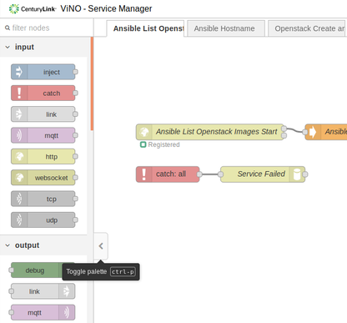

To display a complete description of a node, hover your cursor over it. You can install additional nodes into the palette using either the command-line or the Palette Manager. See Managing Nodes in the Palette Manager.

## Managing Nodes in the Palette Manager

The Palette Manager enables you to manage nodes and install new nodes into the palette. See the following sections for managing nodes:

* Accessing the Palette Manager
* Managing Nodes
* Adding Nodes to the Palette
* Using Built-In or Third-Party Node-RED Nodes

### Accessing the Palette Manager

To access the Palette Manager:

1. Click the Menuicon drop-down (****).
2. Select **Manage Palette**.

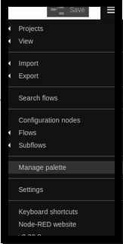

The **User Settings** window opens and displays the **Palette** tab by default as shown Figure 9.

Figure 9. User Settings Window

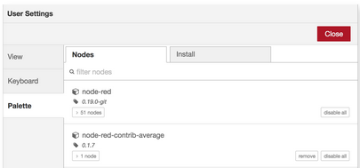

### Managing Nodes

Each entry in the **Nodes** list (Menuicon > **Settings** option > **Palette** tab > **User Settings** window) displays the name and version of each module (bundled nodes) in addition to a list of the individual node types the module provides. Use the Remove, Disable All, and Update buttons as needed to manage modules.

A node that is currently in use cannot be removed or disabled.

Figure 10 shows the **Nodes** listin the **Palette** tab.

Figure 10. User Settings–Nodes List in Palette Tab

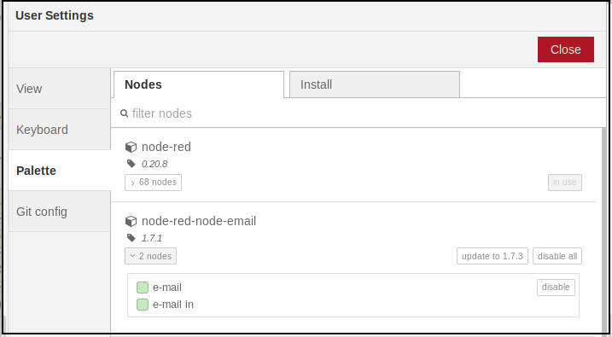

### Adding Nodes to the Palette

The **Install** button (**Palette** tab) enables you to search for available modules (bundle of nodes) and install them.

**Caution**: Third party nodes may not be compatible with ViNO if the nodes do not follow Node-RED standards.

To search for a module, enter its name in the Search field. The search results display the details of the modules, including when it was last updated and a link to its documentation. Figure 11 shows the **Install** tab with an arrow pointing to the documentation icon.

To install the module, click Install.

Figure 11. Palette Install Tab

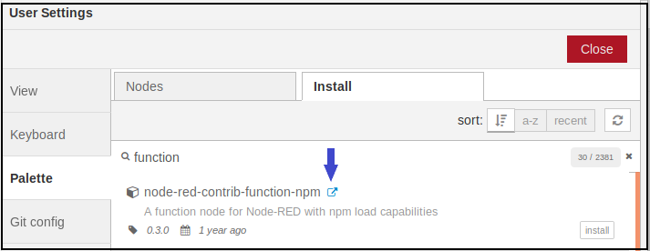

### Using Built-In or Third-Party Node-RED Nodes

As part of a service definition, it may be necessary to incorporate nodes that are not included with ViNO. While other nodes can be freely mixed in within ViNO service flows, additional steps may be taken to make them useful. The output of non-ViNO nodes can only interface with ViNO input and output parameters using the utility nodes provided with ViNO (for example, the service status, parameter wrapper, and throw nodes).

Due to limitations in the Node-RED flow activation procedure, not all third-party nodes function correctly in ViNO service flows. A third-party node that replaces the message passed into it with its own object rather than modifying it prevents a service flow from activating correctly. Consider the implications before you modify the **msg** object mid-flow to prevent ViNO service failures.

## Working with Flow Tabs

A flow is represented as a tab (a flow tab) within the Service Manager workspace and is the main way to organize nodes.

The term *flow* is used for a single set of connected nodes and for the tabs in the Service Manager, which can contain multiple flows (sets of connected nodes). A *project* includes the flow tabs and subflows in the Service Manager.

Figure 12 shows seven flow tabs in the Service Manager workspace.

Figure 12. Service Manager Flow Tab Navigation Bar



Double-click a flow tab to open the **Edit Flow** sidebar, which displays the name, status, and description (if provided) of the flow. You can enter a description as needed. Figure 13 shows an example of the **Edit Flow** sidebar.

Figure 13. Edit Flow Sidebar

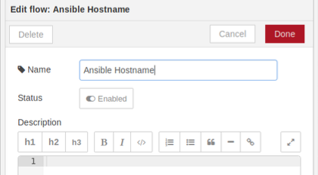

Refer to the following sections for information on managing flow tabs:

* Adding a Flow Tab
* Editing Flow Tab Properties
* Enabling or Disabling a Flow Tab
* Deleting a Flow Tab
* Switching Between Flows

### Adding a Flow Tab

To add a new flow, either click the Plus icon ( ) in the flow tab navigation bar (see Figure 12) or  
double-click any free space in the tab bar. A flow tab can be reordered by dragging it in the tab bar.

### Editing Flow Tab Properties

To edit the properties for a flow tab or to enable or disable a flow, double-click the tab in the top bar to open the **Edit Flow** sidebar as shown in Figure 13. Enter a name and description for the flow. The description can use Markdown syntax for formatting and appears in the Information sidebar.

To change the status of a flow, toggle the current status in the **Status** field. If a flow tab is disabled, none of the nodes it contains are created when the flow tab is deployed.

### Enabling or Disabling a Flow Tab

To enable or disable a flow tab, double-click the tab in the top bar to open the **Edit Flow** sidebar  
(see Figure 13). To change the status, toggle the current status in the **Status** field.

When a flow tab is disabled, none of the nodes it contains are created when the flow tab is deployed. For example, if you have an unfinished flow and save it, the save process fails and displays errors. If you first disable the flow, you can save successfully.

### Deleting a Flow Tab

To delete a flow tab, click Delete in the **Edit Flow** sidebar. See Figure 13.

### Switching Between Flows

To display a list of the available flow tabs, click the Menuicon in the top bar. Click the flow tab you wish to open. The display only lists flow tabs. It does not list subflows (even though they are listed in the tab bar).

## Working with Nodes

The Service Manager palette includes a set of nodes that are the basic building blocks for creating flows. Nodes are joined by wires using their ports. A node can have only one input port but many output ports. A port may have a label that is displayed when you hover your mouse over it. A node may specify labels (for example, the **switch** node shows the rule that matches the port). You may also customize the name of a node by double-clicking the icon (in the workspace) and populating the **Name** field.

When a node has undeployed changes, it displays a blue circle above it. If there are errors with its configuration, the node displays a red triangle.

Certain nodes include a button on either the left or right edge. These buttons enable interactions with the node from within the editor. The **inject** and **debug** nodes are the only core nodes that have buttons.

To display a complete description of a node, hover your cursor over it in the palette.

Refer to the following sections for information on core nodes:

* Using the Inject Node
* Using the Debug Node
* Using the Function Node
* Using the Change Node
* Using the Switch Node
* Using the Template Node
* Using ViNO Nodes
* Using Conditional Start and Conditional End Nodes
* Adding Status Messages to Built-In Nodes
* Using the Function Node to Manipulate Parameters

### Using the Inject Node

The **inject** node enables you to manually trigger a flow by clicking the node’s button within the editor. This node can also be used to automatically trigger flows at regular intervals.



The message sent by the **inject** node can have its payload and topic properties set. The payload can be set to one of the following types:

* Flow or global context property value.
* String, number, Boolean, buffer, or object.
* Timestamp (in milliseconds) since January 1st, 1970.

### Using the Debug Node

The **debug** node enables you to display messages in the **debug** sidebar within the editor.



The sidebar provides a structured view of the messages it is sent, which makes it easy to explore the message. In addition to the message, the debug sidebar includes information about the time the message was received and which **debug** node sent it.

A **debug** node can also be configured to send all messages to the runtime log or to send a short (32 characters maximum) message to the status text under the **debug** node in a flow. Use the button on the node to enable or disable its output.

### Using the Function Node

The **function** node enables JavaScript code to be run against the messages that are passed through it.



### Using the Change Node

The **change** node enables you to modify the properties of a message and set context properties without having to resort to a **function** node.



Each **change** node can be configured with multiple operations that are applied in order. The available operations are:

* **Set** – Set a property. The value can be a variety of different types (displayed in the drop-down in the node Properties window) or can be taken from an existing message or context property.
* **Change** – Search and replace parts of a message property.
* **Move** – Move or rename a property.
* **Delete** – Delete a property.

### Using the Switch Node

The **switch** node enables messages to be routed to different branches of a flow by evaluating a set of rules against each message.



The **switch** node is configured with the property to test, which can be either a message property or a context property. The node routes a message to outputs corresponding to matching rules. You can also configure the **switch** node to stop evaluating rules when it finds one that matches. There are four types of rules:

* **Value** rules are evaluated against the configured property.
* **Sequence** rules can be used on message sequences, such as those generated by the **split** node.
* **JSON Data Expression** rules can be evaluated against the entire message and matches if the expression returns a true value.
* **Otherwise** rules can be used to match if none of the preceding rules have matched.

### Using the Template Node

The **template** node enables you to generate text using a message’s properties to fill out a template.



This node uses the Mustache templating language to generate the result.

### Using ViNO Nodes

Table 11 describes the custom nodes provided with ViNO.

Table 11. ViNO Nodes

| Node | Description |
| --- | --- |
| **service status** | Enables a designer to output arbitrary status messages during activation. Status messages are visible while they are activating and deactivating. |
| **conditional end** | Place this node at the end of a conditional branch. Parameters in nodes on conditional branches that need to be accessed by subsequent steps should be defined in the output parameters of this node.  This node is deprecated and will be removed in a later version. |
| **conditional start** | Manages a conditional branching of service flow logic. This node provides parameters to define the Left Hand Side and the Right Hand Sideoperands of a Boolean expression in addition to the operation to perform and the data type of the operands.  This node is deprecated and will be removed in a later version. |
| **deactivation endpoint** | When the service finishes with the **deactivation endpoint** node, the database elements related to that activation are updated (for example, with status changes). |
| **loop end** | Used to connect back to the input of a loop start node. Place this node at the end of a loop body. |
| **loop start** | Manages a loop in the service flow. This node contains the parameter that controls the number of iterations to perform. Each **loop start** must have a matching **loop end** to connect back to the **loop start**. |
| **parameter wrapper** | Enables arbitrary input parameters to map to properties of the **msg** object that is passed to a following node. Parameter wrappers can be used to:   * Inject ViNO parameters into the Node-RED **msg** object. * Extract attributes from the msg object and convert them into ViNO parameters. |
| **service endpoint** | When the service finishes with the **service endpoint** node, the database elements related to that activation are updated (for example, with status changes).  Each ViNO service must end with a **service endpoint** node (unless your service needs to end with a **service failure** node or a **deactivation endpoint** node). |
| **service entrypoint** | Creates an HTTP end-point for a service.  **Note:** Each ViNO service must start with a **service entrypoint** node**.** |
| **service failure** | When the service finishes with the **service failure** node, the database elements related to that activation are updated (for example, with status changes). |
| **throw** | Throws an error. This node is useful when used in conjunction with a **conditional** node to check whether a particular value is valid. This node generates a service failure or a rollback (depending whether a deactivation flow is defined). The **throw** node is typically paired with a **catch** node to facilitate proper error handling. |
| **vino driver ansible** | ViNO driver node that performs Ansible operations. This node runs an Ansible playbook on the provided target system. The playbook provided can be templated using the [Mustache](https://freemarker.apache.org/) templating syntax. All input parameters on the Ansible node are available for use within the playbook template and can be referenced with {{parameter_key}} anywhere in the playbook.  To use the key-init features of this node with Openstack, you must generate a public and a private SSH key for ViNO to interact with Openstack.  This node enables the use of a private key to authenticate requests against a remote server. For this to work, the private key must be readable by the root user of the vino-core docker container. To accomplish this, place the private key in a docker volume accessible to the vino-core container. The easiest way to do that is after the ViNO services are running, place the private key file in **/var/lib/docker/volumes/<project name>_ViNO-Common/_data/**  Files placed in this directory will be available at the path **/opt/vino/common** inside the vino-core container. The *project name* is the value configured when ViNO was initialized.  The **vino driver ansible** node contains the input parameter **SSH Private Key** that should be configured with the full path to your private key inside the vino-core container. As an option to using the SSH Private Key, you can use the username and password parameters available on this node. |
| **vino driver netconf** | ViNO driver node that performs Netconf operations. This node performs a Netconf get or edit on the provided target system. The node takes in a Netconf template that uses the [Mustache](https://freemarker.apache.org/) templating syntax similar to the Ansible node.  To use the key-init features of this node with Openstack, you must generate a public and a private SSH key for ViNO to interact with Openstack.  This node enables the use of a private key to authenticate requests against a remote server. For this to work, the private key must be readable by the root user of the vino-core docker container. To accomplish this, place the private key in a docker volume accessible to the vino-core container. The easiest way to do that is after the ViNO services are running, place the private key file in **/var/lib/docker/volumes/<project name>_ViNO-Common/_data/**  Files placed in this directory will be available at the path **/opt/vino/common** inside the vino-core container. The *project name* is the value configured when ViNO was initialized.  The **vino driver netconf** node contains the input parameter **SSH Key** that should be configured with the full path to your private key inside the vino-core container. As an option to using the SSH Key, you can use the username and password parameters available on this node. |
| **vino driver openstack** | ViNO driver node that performs OpenStack operations. |

### Using Conditional Start and Conditional End Nodes

In some cases, it may be necessary to only perform actions in a service under a certain condition. For example, if you need to perform operations on a VM that may or may not exist, you can use a condition to determine whether the VM exists.

The **conditional start** and the **conditional end** nodes are deprecated and will be removed in a later version.

While setting up conditional logic is possible in a standard Node-RED instance, ViNO provides the conditional start and the conditional end nodes to simplify this process and make it more compatible with the concept of input and output parameters. The **conditional start** node represents the beginning of a conditional branch of execution. This node includes the following input parameters that control how the Boolean expression is to be evaluated at activation time. The **conditional start** node compares the two values in the **Left Hand Side** and the **Right Hand Side** using the specified operator and executes one of two paths depending on the result.

* **Left Hand Side** – Left hand side operand of the expression.
* **Operation** – Comparison operator to use (equals, less than, less than or equal, greater than, greater than or equal).
* **Operand Data Type** – Data type of the two operands (string, number, or Boolean).
* **Right Hand Side** – Right hand side operand of the expression.

The top output of the node is intended to connect to the steps to take if the condition evaluates to false while the bottom output connects to the nodes to activate if it evaluates to true. Figure 14 shows an example of using a **conditional start** node.

Figure 14. Example of Using the Conditional Start Node

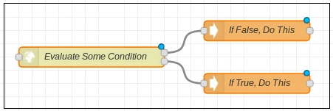

The data type of the **Left Hand Side** and the **Right Hand Side** of input parameters is always **string** and the operand data type parameter controls which type those values are converted to at runtime. Therefore, it is important to ensure the values in those parameters are valid for the configured operand data type. If the values are invalid, they trigger an error during activation.

When the operand data type is set to string or Boolean, only the **eq** (Equals Comparison) operation can be used.

The **conditional start** node also contains a single output parameter (Evaluation Result) that contains the result of the comparison.

At the end of both the true and false branches, the last nodes in each branch must be joined back into a single **conditional end** node (shown in Figure 15). This node provides a clear indication where the conditional branching has ended and the service resumes a normal path. The **conditional end** node also serves an important role in parameter mapping.

Figure 15. Example of Using the Conditional End Node

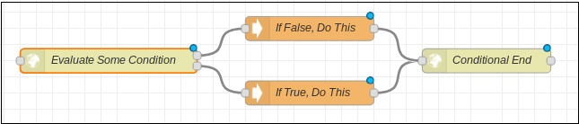

It is a requirement that both branches of the **conditional start** node eventually connect back to a single **conditional end** node. If only one of the branches needs to perform actions, the other branch should have its output connected directly to the **conditional end** node as shown in Figure 16.

Figure 16. Example of Using Conditional Start and Conditional End Nodes

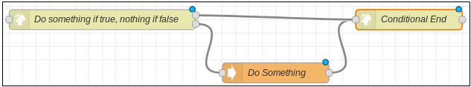

### Adding Status Messages to Built-In Nodes

It may often be helpful to display status information about operations being performed by built-in nodes. To display status information, use the service status node, parameter mapping, and the built-in Mustache templating in the status message to display information extracted from the node.

The **service status** node enables you to output arbitrary status messages during activation. The message can use Mustache-style templating syntax to inject the input parameters defined on this node into the status message. This is useful for including output data from a previous step in the status by:

1. Creating a new input parameter.
2. Mapping it to a previous node's output.
3. Referencing it in the **Message** template.

Properties of the message object can also be referenced in the template by using msg*.nameOfProperty*.

### Using the Function Node to Manipulate Parameters

There may be situations in which parameters need to be manipulated during an activation. For example, it may be necessary to concatenate two or more input parameters or perform some arithmetic on a value. This can be achieved using the **function** node. This node enables you to write JavaScript functions and directly manipulate the message object passed in Node-RED.

By injecting parameters into the message object and then accessing them in a **function** node, you can leverage the power of a full-featured scripting language to manipulate input parameters. After the parameter values are manipulated, the parameters can be injected on to the message object and extracted into an output parameter.

An example to use the **function** node to concatenate objects would be:

var first= 'Jane ';

var last = 'Doe ';

msg['full_name '] = first + ' ' + last;

return msg;

Within the **function** node the message object is referenced with **msg**. The original **msg** object (or a copy of that object) must always be returned at the end of a function. Returning a new object that lacks information injected into it by the ViNO nodes breaks the service flow and causes errors in activation.

## Working with Wires

Nodes are wired together by clicking the left-mouse button on a node’s port, dragging to the destination node, and then releasing the mouse button as shown in Figure 17.

Figure 17. Working with Wires

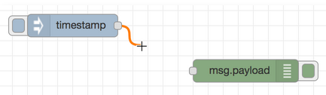

When you drag a node with both an input and output port over the mid-point of a wire, the wire is drawn with a dash. If the node is then dropped, it is automatically inserted into the flow at that point. Figure 18 show how to drop a node on a wire to insert it mid-flow.

Figure 18. Dropping a Node on a Wire

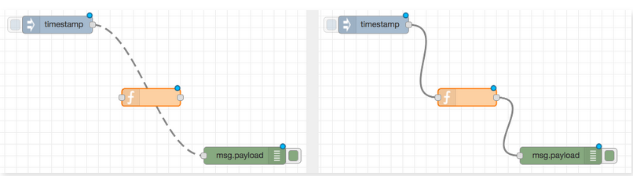

### Moving Wires

To disconnect a wire from a port, select the wire by clicking on it, then press and hold the Shift key when the left-mouse button is pressed on the port. When you drag the mouse, the wire disconnects from the port and can be dropped on another port. If you release the mouse button over the workspace, the wire is deleted.

### Deleting Wires

To delete a wire, select it by clicking on it and then press the Delete key.

## Working with Subflows

Subflows enable a group of nodes to be packaged into a reusable piece of logic that is represented as another node in the palette. These subflows can then be used as part of parent flows. A parent flow is a flow that contains subflows. Conceptually, subflows are the equivalent of subroutines in traditional programming languages.

To create a subflow:

1. Open the Service Manager.
2. Click the Menuicon (see Figure 19).
3. Navigate to **Subflows**.
4. Select **Create Subflow**.

Figure 19. Create Subflow Option

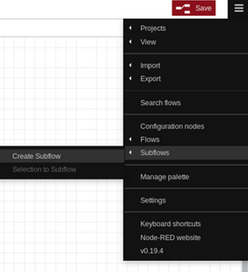

This action opens a new tab that is almost identical to a normal flow tab with the addition of a small tool bar at the top. The tool bar enables you to:

* Control the number of inputs and outputs in the subflow.
* Open a menu to change subflow properties.

Figure 20 shows a new subflow (Subflow 1) and the toolbar.

Figure 20. Example of New Subflow and Toolbar



In most cases, subflows should have a single input and output that are represented as special nodes in the subflow editor as shown in Figure 21.

Figure 21. Subflow Example

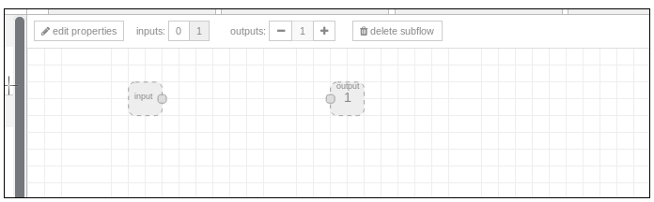

### Designing a Subflow

To design a subflow:

1. Connect nodes starting from the input.
2. When the flow is complete, connect the last node to the output.

Subflows should not contain **service entrypoint** or **service endpoint** nodes because the subflow does not represent a ViNO service, but rather a small unit of work that is intended to be included in other services.

## Working with Messages

A flow works by passing messages between nodes. The messages are simple JavaScript objects that can have a set of properties. Messages usually have a **payload** property, which is the default property (or object) that most nodes work with. Messages also include an identifier property called **_msgid** that traces a node's progress through a flow. The value of a message property can be a valid JavaScript type, such as:

* Boolean
* Number
* String
* Array
* Object
* Null

### Changing Message Properties

A common task in a flow is to modify the properties of a message as it passes between nodes. For example, the result of an HTTP request may be an object with many properties, of which only some are needed. There are two main nodes for modifying a message:

* **function** node – Enables you to run JavaScript code against the message. This gives you complete flexibility in what is done with the message, but does require familiarity with JavaScript and is unnecessary for many simple cases. See Using the Function Node.
* **change** node – Provides functionality without the need to write JavaScript code. This node modifies message properties and also accesses flow- and global-context. See Using the Change Node.

### Using the Service Status Node

The service status node enables you to inject custom status messages at any stage into a service. The message displayed is provided in the node configuration and can be templated using the Mustache syntax to display input parameters defined on the node by referencing them with {{parameter_key}}. This feature is useful for displaying status for non-ViNO nodes that do not write status messages.

## Working with the Sidebar

The sidebar contains icons that provide tools within the Service Manager:

*  Node information – View information about nodes.
*  Project history – Displays changes to local files and changes to commit.
*  Debug messages – View messages passed to debug nodes.
*  Informational dropdown that lists the display options.

Figure 22 shows the display screen for Node Information.

Figure 22. Service Manager Sidebar

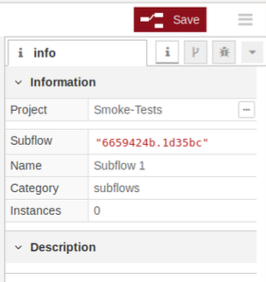

To open a display, click an icon in the header of the sidebar or, select it from the **Informational** drop-down C:\8b0ca8c34860ad05068e019eb48407a5.

## Using Parameters

One of the main features of ViNO is how it handles the parameters used to drive service activations. There are two types of parameters that apply to ViNO nodes:

* **Input parameters** – Control how each step activates a service.
* **Output parameters** – Hold information that is output by a step in a flow that may be useful later in the service.

Parameters are unique to the custom nodes provided with ViNO. However, you can use these parameters to manipulate other Node-RED nodes using the **parameter wrapper** node with the **Mode** set to **Parameter Injection/Extraction** to inject and extract data into a Node-RED message.

Refer to the following sections for information on using parameters.

* Configuring Parameters on Nodes
* Editing Parameters
* Using Parameter Mapping
* Using Parameter Mappings and Conditionals
* Using Parameter Wrapper Injection and Extraction
* Using Parameter Combiner Modes
* Passing Parameters Between a Parent Flow and Subflow

### Configuring Parameters on Nodes

Parameters are configured on a node in the **Property Edit** window. Double-click a node to open the **Property Edit** window specific to that node. Figure 23 shows an example of the **Property Edit** window for the **loop start** node. Depending on the node selected, additional fields may be displayed.

Figure 23. Property Edit Window

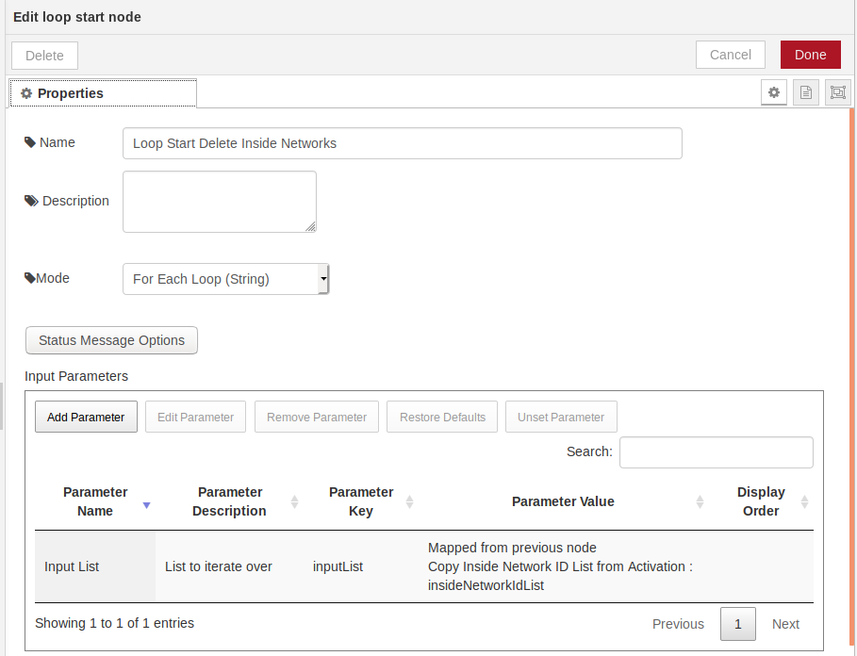  
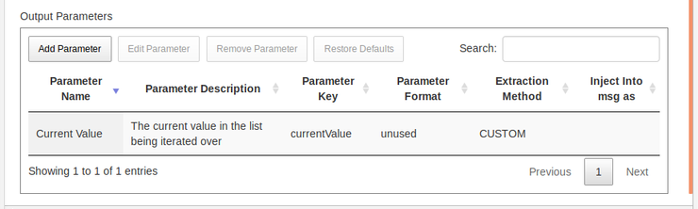

Table 12 describes the fields, buttons, sections, and columns in the **Property Edit** window.

Table 12. Property Edit Window

| Component | Description |
| --- | --- |
| Top navigation bar | * **Delete** – Deletes the node. * **Cancel** – Cancels changes you made in Edit mode. * **Done** – Saves changes and closes the Edit Parameters window. |
| **Name** field | Displays the name of the node in the flow. |
| **Description** field | Displays a description of the node (if one was entered when the parameter was added). |
| **Command** field | Determines the action the node takes for a step. |
| **Status Message Options** button | This button enables you to limit the type of messages per node that are displayed at activation. Select **Always**, **Debug mode only**, or **Never** from each drop-down as needed:   * **Display Node Starting Messages** * **Display Node Completed Messages** * **Display Retry Messages** |
| **Input Parameters** section | Displays the parameters configured for the node. Provides buttons to add, edit, or remove parameters as well as restore defaults and unset parameters. These functions are listed in the following rows. |
| **Add Parameter** button | Opens the **Edit Input Parameter** window enabling you to add a new parameter. Depending on the option selected in the **Type** and **Parameter Source** fields, other fields may be displayed.  The following fields apply to all nodes:   * **Name** – Enter a descriptive name for the parameters. * **Key** – This field auto-populates as you type in the **Name** field. * **Description** – Enter a description of the parameter. * **Type** – Select a type from the drop-down. * **Parameter Source** – Select a source from the drop-down:   **Node Configuration** – Requires you to add a value in the **Value** field.  **Message** – Requires you to add a name in the **Message Property Name** field. Enables you to get a value from the Node-RED message object and use it as the parameter source.  **File Reference** – Select a file from the **Project Files** drop-down or upload a file. Enables you to use a value in a file as the parameter source.  **Constants** – Enables you to use a constants file as the parameter source. Requires you to enter a path in the **Constants Path** field using the value in the **Name** fields for the settings. For example, **/categoryName/groupName/scalarName**. Several constants are pre-populated as you type.  **Mapped from another Node (ViNO Service Only)** – Enables you to select the node that has the parameter you want to map from (in the **Mapped From Node** field). You must then select the key you want to map from in the **Mapped from Key** field.   * **Display Order Index** – Use the arrow buttons to determine the order in which parameters are displayed. The lower the number, the higher the entry appears in the display. * **Optional** – Select this button to make the parameter optional. If **Optional** is not selected, the parameter is required by default to activate the service. * **Final** – Select this button to disable the ability to change the parameter at activation. Parameters that have this option selected are not displayed in on the **Activation** screen. |
| **Edit Parameter** button | Opens the **Edit Input Parameter** window enabling you to edit parameters for a specific node. Highlight a node entry and then click Edit Parameter (or double-click a parameter). Includes similar fields as the Add Parameter button. |
| **Remove Parameter** button | Enables you to remove user-added parameters. You cannot remove built-in parameters. |
| **Restore Defaults** button | Restores the default value (as displayed in the **Parameter Value** column) for the selected parameter. |
| **Unset Parameter** button | Clears the value (as displayed in the **Parameter Value** column) for the selected parameter. |
| **Parameter Name** column | Displays the name of the input parameter. |
| **Parameter Description** column | Displays a description of the input parameter if one was entered in the Description field. |
| **Parameter Key** column | Displays the input parameter key for the node. |
| **Parameter Value** column | Displays the input parameter value if one has been configured on the node or displays the source for the value. |
| **Display Order** column | Displays a parameter in a specific order if the Display Order Index field is set. |
| **Output Parameters** section | Displays the parameters that are configured to contain the output of the node. Provides buttons to add, edit, or remove output parameters as well as restore defaults. These functions are listed in the following rows. |
| **Add Parameter** button | Open the Edit Output Parameter window enabling you to add an attribute to the Node-RED message object that contains the value of the output parameter.   * **Name** – Enter a descriptive name for the parameters. * **Key** – This field auto-populates as you type in the **Name** field. * **Description** – Enter a description of the parameter. * **Type** – Select a type from the drop-down. * **Extraction Method** – Select a method from the drop-down to determine how data is extracted from the output of a node. If you select REGEX, XPATH, or JSONPath, you must provide a valid rule in the **Format** field. * **Format** – Enter a valid rule if you selected REGEX, XPATH, or JSONPath as an extraction method. * **Inject into msg as** – Enables you to inject the ViNO output parameter into the Node-RED msg object using the identifier entered in this field. * **Private** – This checkbox prevents other nodes from being able to use parameter mapping to reference this output parameter. |
| **Edit Parameter** button | Opens the **Edit Output Parameter** window enabling you to edit parameters for a specific node. Highlight a node entry, then click Edit Parameter. Or, double-click a parameter. Includes the same fields as the Add Parameter button. |
| **Remove Parameter** button | Enables you to remove user-added parameters. You cannot remove built-in parameters. |
| **Restore Defaults** button | Restores the default value (as displayed in the **Parameter Value** column) for the selected parameter. |
| **Parameter Name** column | Displays the name of the output parameter. |
| **Parameter Description** column | Displays a description of the output parameter if one was entered in the Description field. |
| **Parameter Key** column | Displays the output parameter key for the node. |
| **Parameter Format** column | Displays the rule entered in the Format field. This value displays when REGEX, XPATH, or JSONPath was selected as an extraction method. |
| **Extraction Method** column | Displays the method as set in the Extraction Method field. |
| **Inject into msg as** column | Displays the identifier entered in the Inject into msg asfield. |

### Editing Parameters

To edit a parameter, select it from the **Input Parameters** section of the Property Edit window, and then click **Edit Parameter** or double-click the parameter name. Figure 24 shows an example of the **Edit Input Parameter** window.

Figure 24. Edit Input Parameter Window

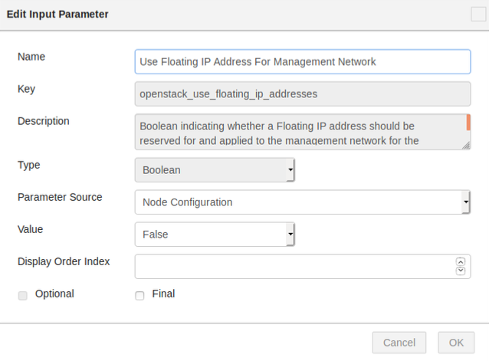

The **Edit Input Parameter** window includes fields and checkboxes that control the behavior of parameters and the **Value** field in which a fixed value can be set. Because this parameter is built into the action, some fields and options are disabled. When the parameter is configured to come from constants or is mapped from another node, additional fields appear that enable you to configure which constant to lookup or to which node and parameter to map.

* The **Final** checkbox controls whether the value can be overridden at activation time. When mapping from another node, the **Final** checkbox cannot be selected.
* The **Optional** checkbox controls whether the service can activate with or without that parameter.

### Using Parameter Mapping

Parameter mapping enables you to reference a parameter value from a node that had been activated previously. For example, you may reference a VM ID in a deactivation step in order to delete the VM. When mapping to previous nodes, map to output parameters (not input parameters).

**Caution**: Do not use the **Import** or **Export** options (Menuicon drop-down) to share or save a project. These functions lose parameter mappings.

### Using Parameter Mappings and Conditionals

ViNO conditional nodes (conditional start and conditional end) present a unique challenge when it comes to parameter mapping. This is because the conditional statement is not evaluated until activation time and its input values may be based on previous steps or user input. The result of the evaluation cannot be known ahead of time. Therefore, there is no guarantee when designing a service that the steps in one particular branch will be executed. For that reason, nodes outside of a particular conditional branch are not permitted to map to parameters on nodes within a conditional branch. However, you may need to use output parameters from steps within a conditional later in the service flow after the conditional branch has completed.

To accomplish this, configure the conditional end node with a unique type of output parameter that handles this situation in a safe manner. Output parameters in the **conditional end** node are configured to map to parameters in both the true and false branches. This functionality imposes the limitation that both branches must contain a parameter that logically makes sense to expose in both the true and false scenarios.

### Using Parameter Wrapper Injection and Extraction

The parameter wrapper node has several different purposes. The **Mode** setting controls the behavior of the node.

When a **parameter wrapper** node has the mode set to **Parameter Injection/Extraction**, the node injects input parameters into the Node-RED message object so that the parameters can be accessed with **msg.parameter_key**. This node also inspects output parameters defined on it and tries to extract the parameters from the Node-RED message object. This functionality is necessary to facilitate the use of non-ViNO nodes in a service flow. The **parameter wrapper** node can also be used to pass parameters into subflows.

### Using Parameter Combiner Modes

The **Parameter Combiner** modes (**Mode** drop-down in the **Property Edit** window) provide a simple way to transform individual scalar parameters in to a single list type parameter. Input parameters added in this mode are included in the **Combined Output List** parameter. The **Parameter Combiner** modes available in the **Mode** drop-down include:

* **Parameter Combiner (String)**
* **Parameter Combiner (Number)**
* **Parameter Combiner (Boolean)**

Figure 25 shows the **Mode** field in the **Property Edit** window.

Figure 25. Mode Field in Property Edit Window

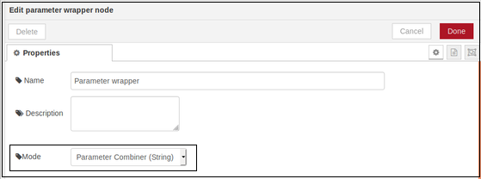

### Passing Parameters Between a Parent Flow and Subflow

Parameters can be passed between a subflow and the parent flow that is using it. When accessing the output parameters of nodes within the subflow from the parent flow, ViNO combines them and presents them as output parameters of the subflow node within the parent flow. However, passing parameters into the subflow is complex because nodes within a subflow cannot use the ViNO parameter mapping functionality to directly map to any parameters in a parent flow. This is because subflows can be used in different flows. To work around this, use the parameter wrappernode with the **Mode** set to **Parameter Injection/Extraction**.

At the start of the subflow, add a **parameter wrapper** node and define output parameters to contain any values you want to pass into the subflow from the parent flow.

Nodes within the subflow can now map to those output parameters as needed. To pass those parameters into the subflow:

1. Add another **parameter wrapper** node immediately in the parent flow *before* the subflow.
2. Define input parameters on the **parameter wrapper** node that exactly match the parameter keys from the output parameters created within the subflow.

When the service is activated, the two input parameters in the parent flow are put into the message object, which gets passed into the subflow where they are immediately extracted into two corresponding output parameters. When a flow uses a subflow that requires certain parameters to be passed in and the parent flow fails to do so, the subflow triggers an activation failure due to missing input.

When the subflow requires the parameters for use in built-in nodes, you can omit the **parameter wrapper** node at the start of the subflow. This is because the parent flow has already placed the parameters on to the message object so that they can be directly accessed by built-in nodes as is.

Figure 26 shows an example of the Edit Property window for a parameter wrapper node.

Figure 26. Using a Parameter Wrapper Node

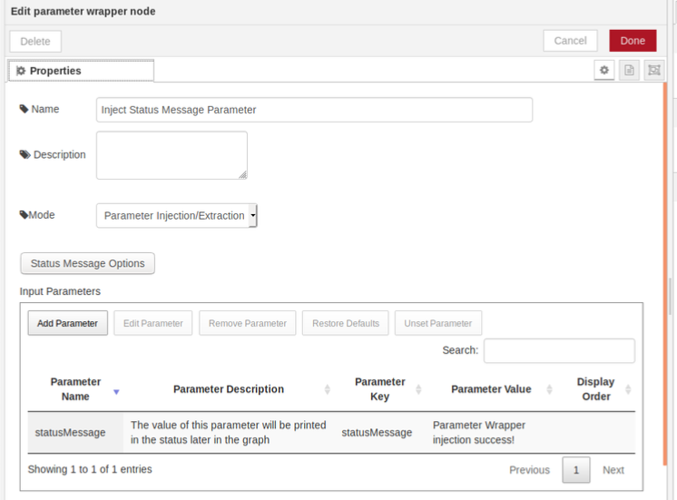  
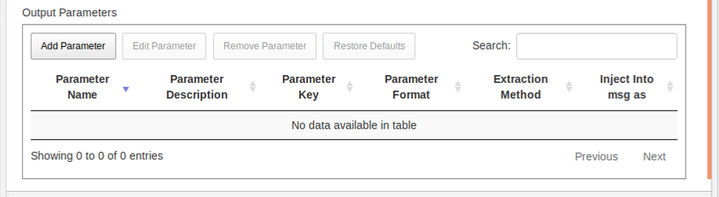

## Using Loops

It may be necessary to repeat a step or a group of steps in a service multiple times. The number of times to repeat these steps may be variable or the input for each iteration may need to vary. The **loop start** and the **loop end** nodes provide two ways to perform a set of actions repeatedly:

* A basic loop that repeats a fixed number of times
* A **for each** loop that iterates over a list and exposes a single element from that list upon each iteration.

Refer to the following sections for information on using loops:

* Using Basic Loops
* Considerations for Each Loop
* Using Input Parameters in a Loop Step
* Using Parameter Mapping and Loops

### Using Basic Loops

A basic loop begins with a **loop start** node that contains a single input parameter (Iterations) that controls the number of times the loop is to repeat. The parameter source can be configured using the same sources available to other input parameters. The **loop start** node contains a single output parameter that always contains the current iteration number of the loop starting from 0. A node within a loop can map any of its parameters to the Iterations input parameter in the **loop start** node.

The **loop start** node has two output ports:

* The top output connects to the start of the steps that are included in the loop (the loop body).
* The bottom output connects to the next step to take after the loop has run to completion.

As shown in Figure 27, at the end of the loop body, the last node must connect to a **loop end** node that must connect back to the input of the **loop start** node.

Figure 27. Example of a Basic Loop

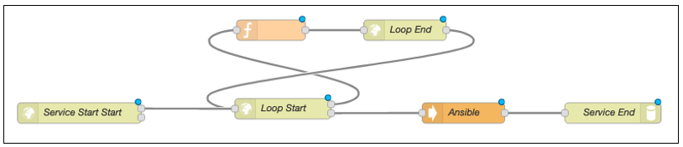

### Considerations for Each Loop

In addition to the basic loop mode, ViNO provides another looping mode that resembles the **for each** construct of many programming languages. This loop mode operates identically to the basic loop mode, but rather than taking a number that controls the number of iterations in the **start** node, the loop takes a list type input parameter called **Input List**. The type of this list is determined by which variation of the **for each** mode is selected (String, Number, or Boolean). There is also a single output parameter (**Current Value**) that contains the value for the current iteration of the loop.

Figure 28 shows the **loop start** node with the **Input List** parameter and the mode set to **For Each Loop** with a string input list. The input list contains three values (VM1, VM2, and VM3), indicating that the loop is to run a total of three times. The **Current Value** output parameter has its value set to VM1 on the first iteration, VM2 on the second iteration, and VM3 on the third iteration.

Figure 28. Using Input List in a Loop

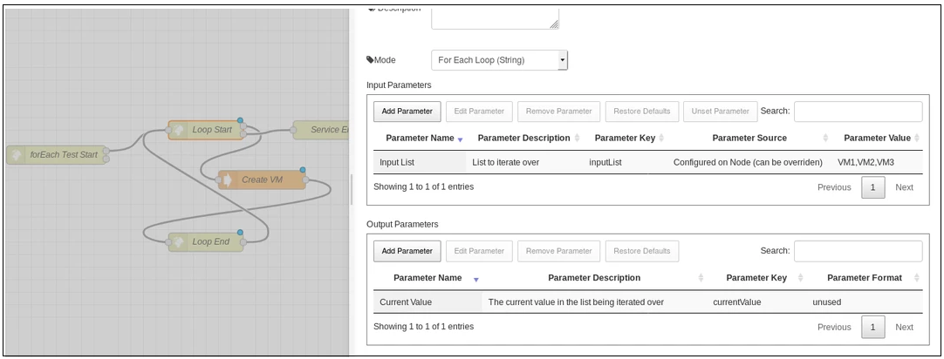

Figure 29 shows the Create VM node with the Virtual Machine Name input parameter value mapped to the **Current Value** output from the preceding **loop** **start** node. Because that parameter changes with each iteration, the end result of this loop would be three VMs with the names VM1, VM2, and VM3.

Figure 29. Loop Start Node Example

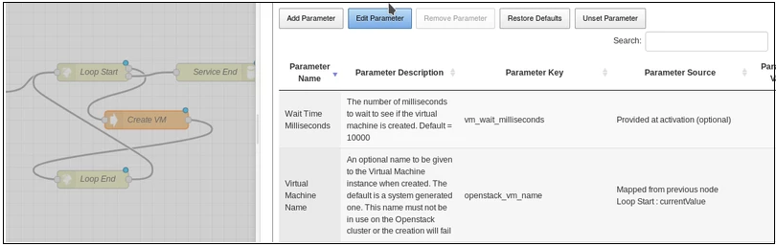

### Using Input Parameters in a Loop Step

To provide flexibility, the input parameters of a node have a unique behavior when the parameters are located inside the body of a loop. When a parameter is configured in a node and not overridden, it uses that fixed value for every iteration of the loop. However, if the input parameter is provided at activation time, its type is converted into a corresponding list type (for example, a string parameter becomes a **stringList parameter**) and the step uses the next value available in that list upon each iteration.

For example, if the “Create VM” step was placed inside a loop, the **VM Name** input parameter would be converted to a **stringList**. The loop could then be configured to run for three iterations and the **VM Name** parameter could be given a list of three different names. This would result in the creation of three virtual machines, each with one of the names provided in the **VM Name** input parameter list. The loop would also wrap around while iterating through input lists, if necessary. Therefore, if a loop runs six times, but a particular input list only contains two values, the loop alternates between those two values for that particular parameter.

### Using Parameter Mapping and Loops

For nodes that map to parameters of nodes within the same loop, parameter mapping works as expected and the mapping copies the value from the node activated within the current iteration. However, if a parameter in a node outside of the loop maps to a parameter in a node within the loop, it always receives the value used or created on the last iteration of the loop.

## Using Parallel Execution

Node-RED and ViNO natively support executing independent steps in parallel. Each node output can have multiple connections to subsequent nodes. To create a parallel branch, create links from one node output to two or more nodes.

Because nodes within parallel branches cannot map to nodes in other branches, parallel logic can only be employed when a series of actions are truly independent.

As shown in Figure 30, after the network is created, the service splits into three branches and begins creating three VMs in parallel.

Figure 30. Example of Creating a Parallel Branch

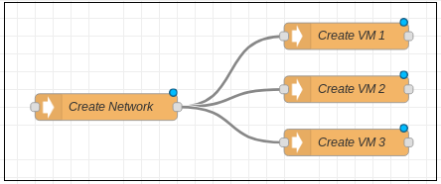

### Joining Parallel Branches

Before a service completes, it must join the parallel branches together at some point. This is a point that halts execution of the service until all branches are finished completely. The last node of each branch must be connected to a single **join** node as shown in Figure 31.

Figure 31. Example of Joining Parallel Branches

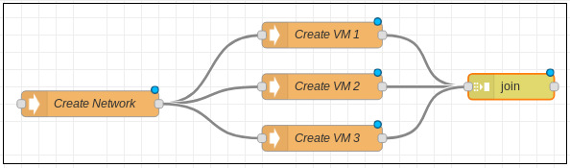

The **join** node must then be configured to expect message from the number of branches that were created. To accomplish this:

1. Open the **Property Edit** window for the **join** node. See Figure 32.
2. Select **manual** mode.
3. (Optional) Select values for the following fields:

* **to create**
* **joined using**
* **After a timeout following the first message**

1. Enter the number of branches being joined in the field **After a number of message parts**.
2. Click Done.

After the branches have been joined, the service can continue as normal and all nodes within the branches can be referenced using parameter mapping.

Failure to configure the **join** node correctly results in undefined behavior.

Figure 32. Example of Join Node Properties

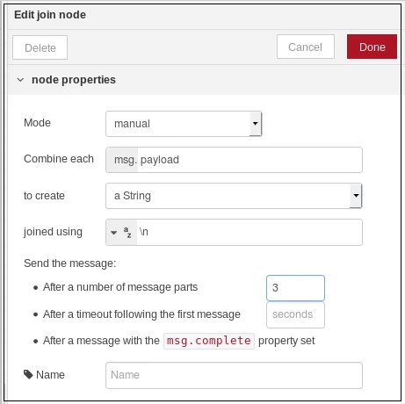

# Creating a Service Deactivation Flow

To create a service deactivation flow, use the service entrypoint node. This node has two outputs available:

* Top output – Used for the service activation flow.
* Bottom output – Meant to be connected to a corresponding flow that would deactivate an instance of the service.

A service flow must have a deactivation path defined in order for the service to be deactivated.

A service deactivation flow works similarly to how the activation flows work with several key differences:

* At the end of a deactivation flow, the last node must be connected to a deactivation endpoint node rather than a service endpoint node.
* Nodes within the deactivation flow can map to parameters from a node in the activation flow. This enables the deactivation flow to access the input and output information that was used or created during a particular activation as part of the deactivation logic. For example, if a VM was created in an activation flow, the flow would need the VM identifier output as part of that step in the deactivation flow to delete the correct VM.
* The deactivation flow ignores errors encountered during deactivation and continues deactivating. This is to facilitate easier rollback logic and ensure that ViNO tears down as much of the service as possible, even if some resources are missing or have been modified since the service activation. Errors in the deactivation flow are still reported in status messages.

Figure 33 shows an example of a simple service with a corresponding deactivation flow.

Figure 33. Service with Corresponding Deactivation Flow

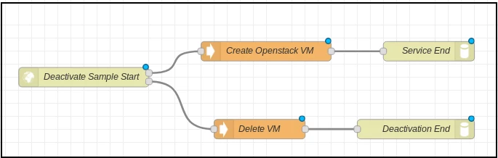

When a deactivation is called on an instance of a service, the inputs and outputs from the activation are retrieved and available for use. Figure 34 shows a deactivation flow that maps to the VM ID output parameter from the activation flow, which deletes the VM associated with that particular activation.

Figure 34. Deactivation Flow Example

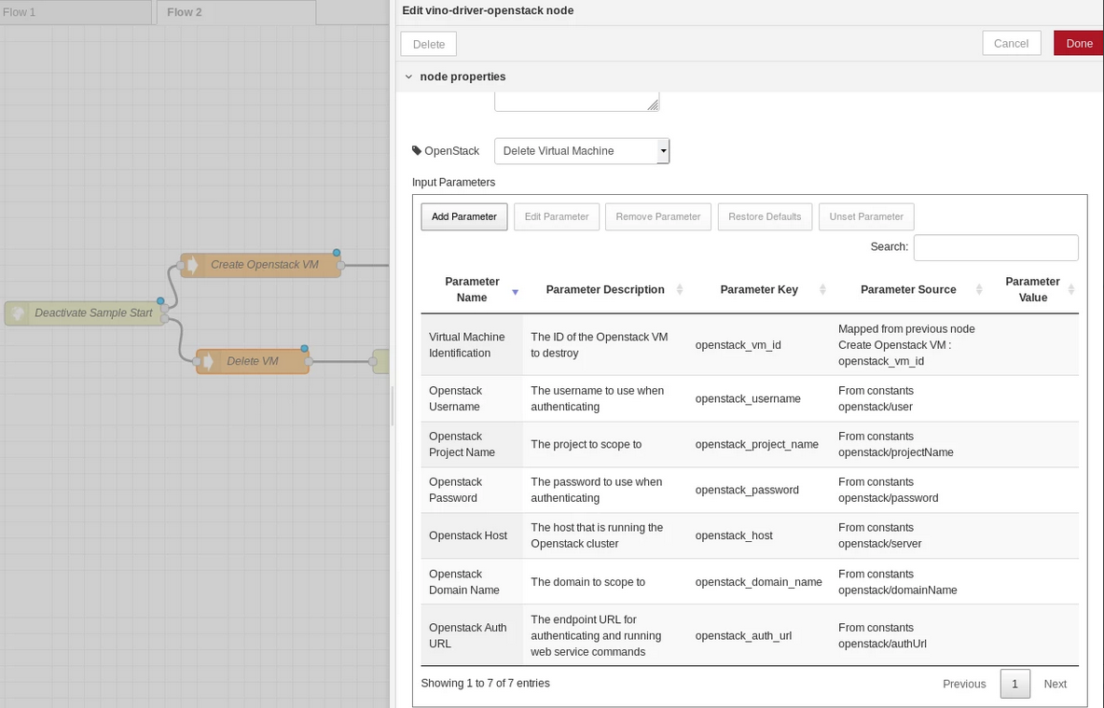

# Error Handling

Due to the complexity of certain service activation flows, errors may occur. For example, if there are invalid or missing inputs or unreachable systems, service activations will fail to complete successfully. It is important to handle cases where failure is a possibility. Node-RED and ViNO include the ability to automatically handle errors using the:

* **catch** node
* **throw** node

## Using the Catch Node

If a node encounters a problem, it triggers an error and stops passing messages to subsequent nodes. The Node-RED **catch** node (located under the input category) can intercept these errors and start executing a flow from an entirely independent location. You can configure the **catch** node to either catch errors from anywhere on the current flow or to only catch errors from specified nodes. This functionality provides flexibility for handling errors.

However, it is necessary to communicate to ViNO in the case of Node-RED errors, which is the function of the service failure node. When a **service failure** node executes, ViNO records that the service activation was a failure and reports this in a status message. When a service encounters an error that is not directed to a **service failure** node, ViNO does not record the activation attempt. Therefore, services should have a minimum of one **catch** node connected to a **service failure** node. Both nodes can be placed anywhere on the same tab as the activation flow.

The **catch** node can also be configured to catch errors only from specified nodes. This can be useful in defining rollback logic for a service. See Adding Rollback Capability.

## Using the Throw Node

The ViNO throw node simply throws an error upon reaching a node. This node functions as a valid end (such as the **service endpoint** and the **deactivation endpoint** nodes) to a ViNO service, which allows the service to complete even in the case of an error.

### Adding Rollback Capability

If a service runs into an error at some point in the activation process, it may be necessary to clean up or revert some of the actions that completed prior to the failure. This can be done by combining the error handling capabilities (see Error Handling) with the deactivation flow.

The service failure node contains an output that may optionally be connected to a node in the deactivation flow. If a service encounters an error and ViNO detects that the **service failure** node is connected to the deactivate flow, it enters rollback mode and indicates that it is now trying to clean up the failed activation. The easiest way to implement rollback is to:

1. Use a single **catch** node and select **all nodes** from the **Catch Errors From** drop-down.
2. Connect it to a **service failure** node.
3. Connect **service failure** node to the first node of the deactivate flow.

Figure 35 shows how to implement a rollback.

Figure 35. Implementing a Rollback

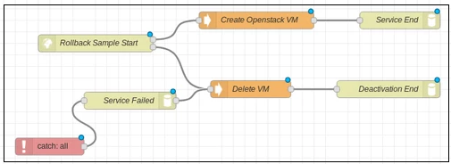

Because nodes in a deactivation flow ignore errors, a rollback always runs to completion even if some of the actions attempting to be deactivated were never activated.